**DAILY ONLINE ACTIVITIES SUMMARY**

|  |  |  |  |  |  |  |  |  |
| --- | --- | --- | --- | --- | --- | --- | --- | --- |
| **Date:** | **27/06/2020** | | | | | **Name:** | **PRANEETA P HANDRAL** | |
| **Sem & Sec** | **4​th​ SEM. & ‘B’ SEC.** | | | | | **USN:** | **4AL19CS401** | |
| **Online Test Summary** | | | | | | | | |
| **Subject** | | **DATA COMMUNICATION** | | | | | | |
| **Max. Marks** | | **30** | | **Score** | | | **23** | |
| **Certification Course Summary** | | | | | | | | |
| **Course** | **Introduction to Cloud** | | | | | | | |
| **Certificate Provider** | | | **Cognitive class** | | **Duration** | | | **6 Hrs.** |
| **Coding Challenges** | | | | | | | | |
| **Problem Statement:** Write a C program to print kth digit.  Given two numbers a and b, find kth digit from right of a^b.  Input:The first line of the input contains T denoting the number of test cases.Each of the next T lines contains three space separated positive integers denoting the value of a , b and k respectively.  Output:For each test case, output the kth digit from right of a^b in new line.  Constraints:  1<=T<=100  1<=a , b <=15  1<=k<=|totaldigits in a^b|  Example:  Input:  2  3 3 1  5 2 2  Output:  7  2 | | | | | | | | |
| **Status:** **Executed.** | | | | | | | | |
| **Uploaded the report in Github** | | | | | **Yes** | | | |
| **If yes Repository name** | | | | | **LockdownCoding**  <https://github.com/praneetahandral/lockdowncoding> | | | |
| **Uploaded the report in slack** | | | | | **Yes** | | | |

**Online Test Summary: 18CS46 test was scheduled from 11:30 am to 12:00pm. The portion for the IA was 5th module there were 30 questions and the time assigned was 30 minutes the questions were mcq type. There were 30 questions of 1 marks respectively.**

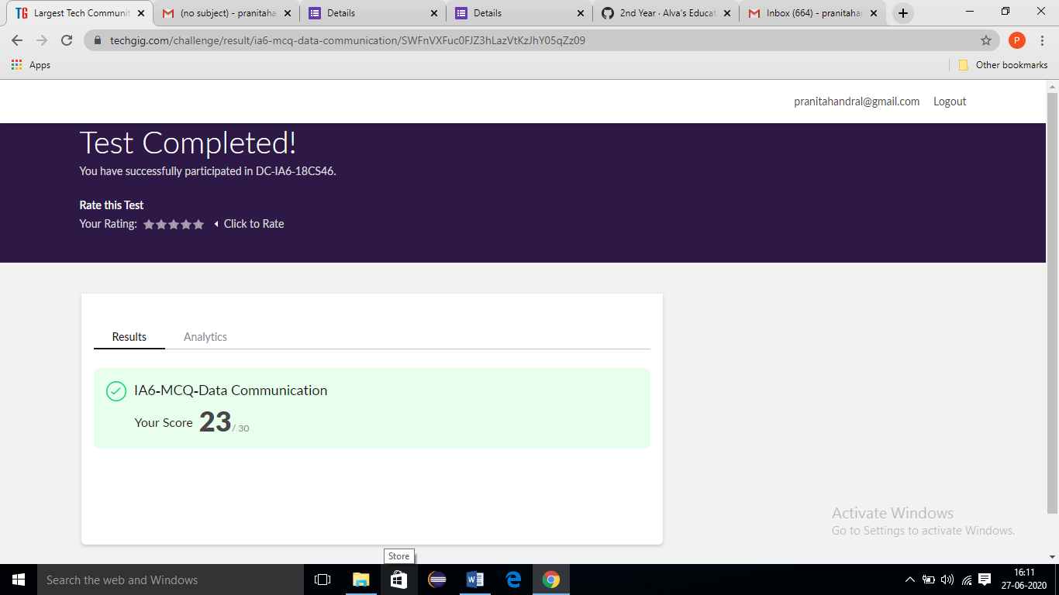

**Online Certification course Summary​:** I have taken my Online Certification Course in **Cognitive class**  the course which I have opted is **Introduction to Cloud**. Course contains videos, tutorials, assessments and quiz. Today I have gone throw **Cloud Adoption and Emerging Technologies** and **Cloud Adoption - Some Case Studies**.

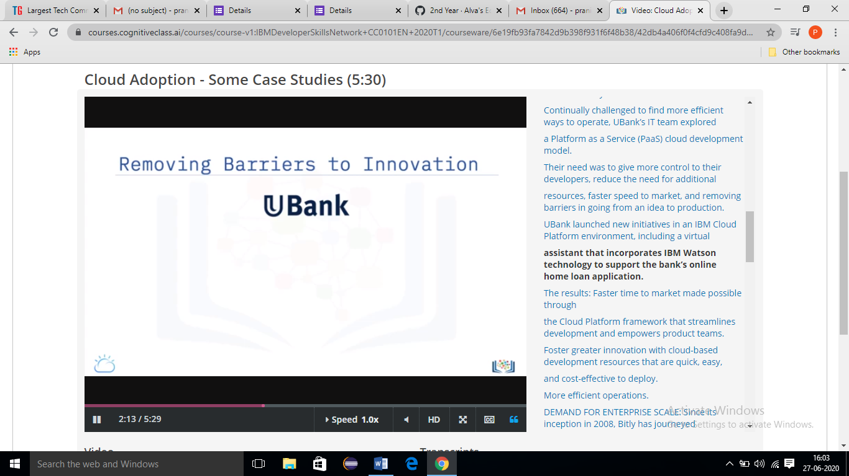

**Online Coding Summary​: Today I received one programs from prof.** **Shilpa CSE Dept I have written one program and uploaded it to my Github repository. This is my repository snapshot. I have uploaded the frequency program.**

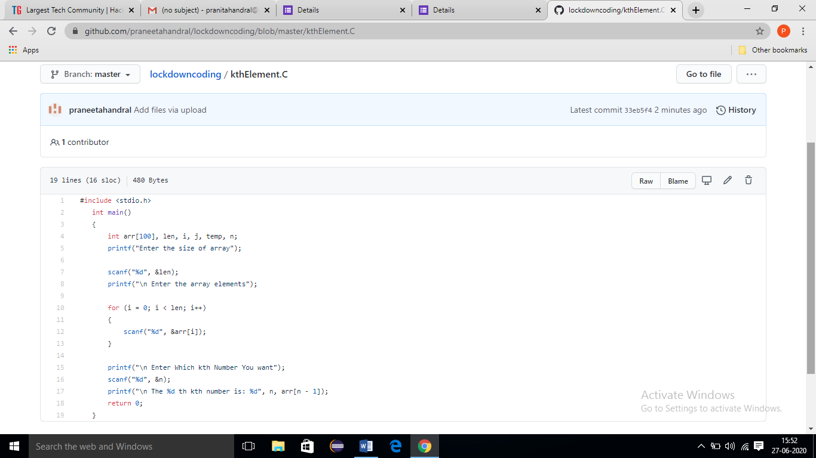

**Online Training**: Today I had attended the online training organized by CSE Dept AIET. The training was on C programming done by Prof. Megha D. Hegde CSE Dept. After the session there is one quiz was conducted. the snapshot that shown in below quiz attempted and the marks obtained.

